Creating Folders and Arranging Files

With Google Docs

Creating a New Folder

Click on the Create New button. A drop down list will appear. Click on Folder.

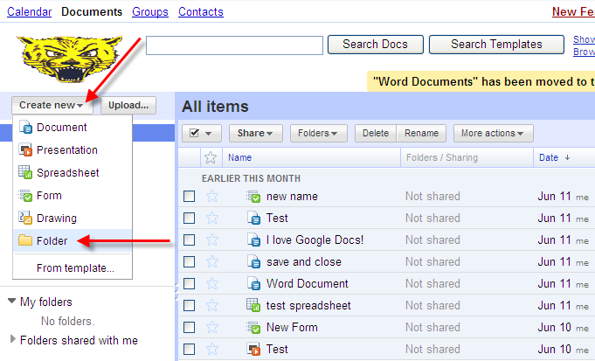

Type in the new name of the folder towards the top of the window and hit Enter on the keyboard. The new name will update in left side menu under My Folders.

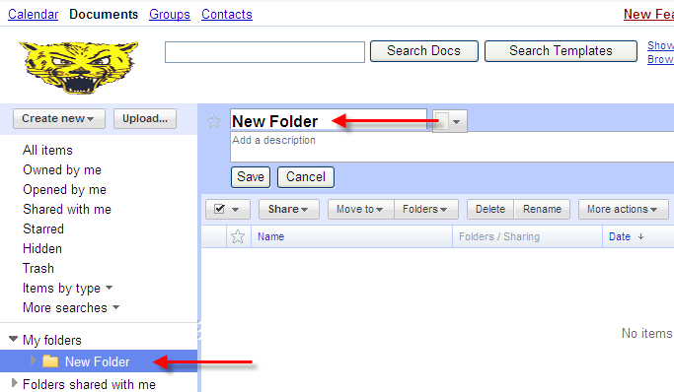

Moving Files into a Folder

- Click on All items in the left side menu.

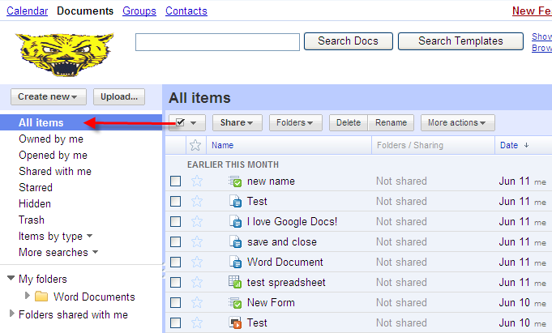

- Check the box of all files to be moved to a folder.

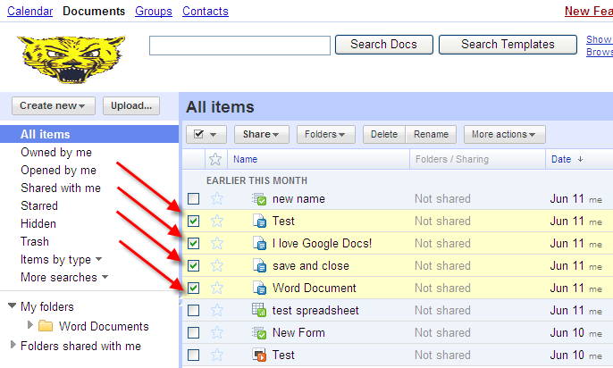

Move to the next page for more steps.

- Click on Folders at the top of the All Items list. A drop down list will appear. Click to check the empty box next to the folder that the files will be added to, and then click the Apply Changes button.

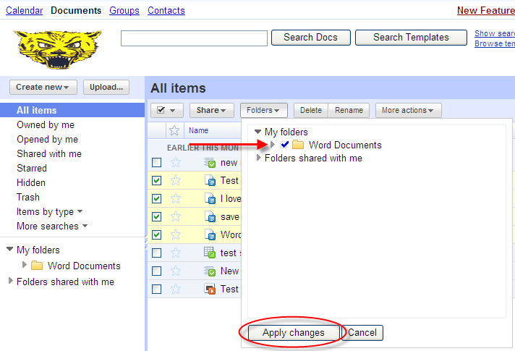

- Click on the folder name in left side menu. The files will be added to the Folder selected. These files will also still be visible in the All items list.

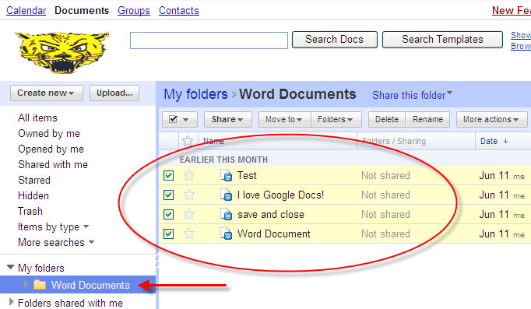

Removing Files from a Folder

- Click on the folder name in the left side menu.

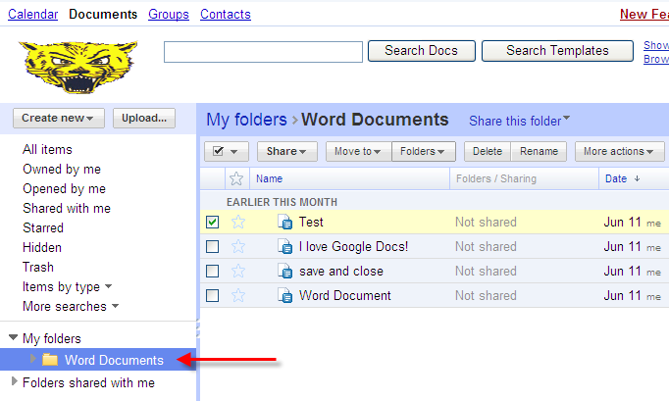

- Check the box of all files to be removed from the folder.

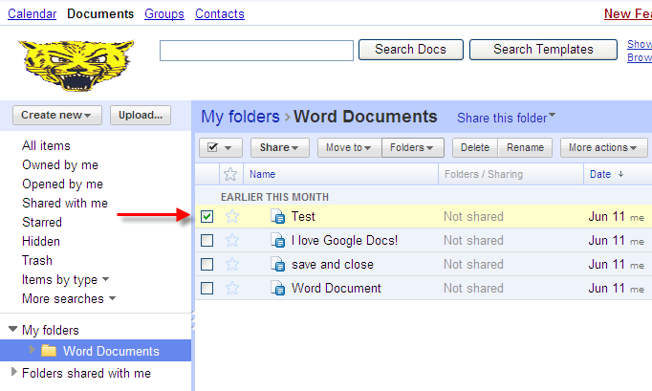

- Click on Folders at the top of the All Items list. A drop down list will appear. Click to uncheck the checked box next to the folder that the files removed from, and then click the Apply Changes button.

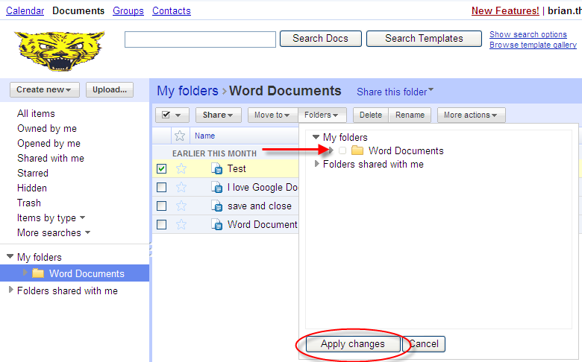

- The file will be removed from the Folder selected. This file will still be visible in the All items list.

